Table of Contents

Abstract 2
1.0 Introduction 2
Research Question: 3
2.0 Methods 3
Three interview questions 4
3.0 Results 4
3.1 Theme 1: Limited Practicality for Everyday Use 4
3.2 Theme 2: Miniature Size as a Source of Fashion Appeal 5
3.3 Theme 3: An Occasional and Symbolic Fashion Accessory 6
4.0 Discussion 6
4.1 Limited Functionality 6
4.2 Miniature Size and Fashion Appeal 6
4.3 Occasional and Symbolic Accessory 7
4.4 Overall Discussion 7
5.0 Conclusion 8
6.0 References 8
7.0 Appendix A: Interview Questions and Participant Responses 9

Small in Size, Big in Impact: Exploring the Jacquemus Le Chiquito Bag

Abstract
This mini research paper explores how the miniature scale of the Jacquemus Le Chiquito bag influences the viewers’ perceptions towards functionality and fashion appeal. A qualitative approach was used with interviews of eight participants being asked three open-ended questions about their first impressions of the bag, its practicality, and its overall attractiveness. The responses were grouped into three main themes: limited practicality for everyday use, miniature size as a source of fashion appeal, and the bag as an occasional or symbolic accessory. The findings suggested that most participants considered the bag impractical because of its limited capacity, but many also viewed the small size to be distinctive, playful, fashionable, and visually appealing. Overall, the study indicated that the Le Chiquito’s miniature scale reduces its functional value but strengthens its role as a recognizable fashion statement.

1.0 Introduction
Fashion accessories can play a role beyond their classic practical functions. For instance, handbags are traditionally designed for carrying personal belongings, however they can also communicate style, identity, status and personal taste. In contemporary fashion, the designers may experiment with unconventional proportions, shapes and materials for new innovative designs which allows their products to be distinguished better and to attract customer attention. Therefore, the visual appearance of a fashion object can be observed as almost as important as its practical function. Thus, it creates an interesting relationship between aesthetic appeal and usability in fashion design.
For instance, the Jacquemus Le Chiquito became widely recognised for its miniature silhouette and distinctive design (Ramzi, 2025). Unlike conventional handbags which are designed to accommodate a range of everyday belongings, the miniature proportions of the Le Chiquito bag significantly limit the things that can be carried. In contrast, its unique scale also makes the bag visually noticeable and easily recognisable. In this scenario, the design challenges the expectation of a handbag being primarily used as a practical storage object, but instead its small size being understood as an intentional fashion statement emphasizing on visual identity, novelty and style.
The Le Chiquito is an interesting object to study how viewers understand fashion design due to its relationship between appearance and practical use. Different individuals may respond differently to its miniature proportions, in which some people might be more interested in its appearance and fashion value, whereas others may pay attention to everyday usefulness. Understanding of different responses can allow understanding on how a single design element such as scale can affect the perception towards the functional and aesthetic qualities of a fashion design object.
Hence, this study focuses specifically on the miniature scale of the Jacquemus Le Chiquito and examines how the viewers react to the correlation between its appearance and perceived usefulness.

Research Question:
How does the miniature scale of the Jacquemus Le Chiquito bag influence viewers’ perceptions of functionality and fashion appeal?

2.0 Methods
Figure 1 Jacquemus Le Chiquito Bag
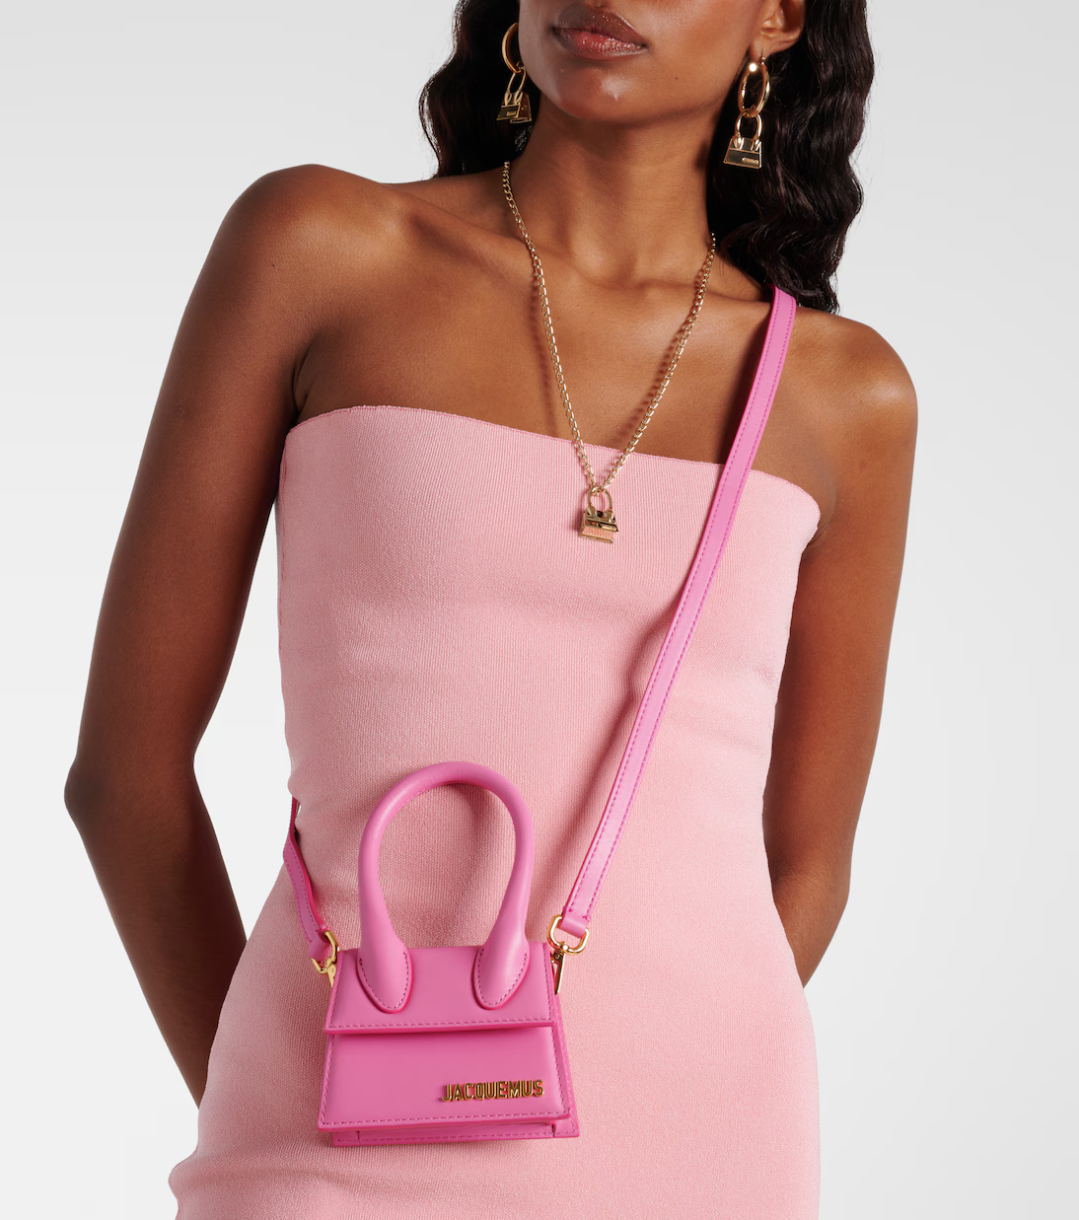
Note. Photograph from Mytheresa (n.d.).
For this project, a qualitative interview approach was utilized to understand how viewers perceive the miniature scale of the Jacquemus Le Chiquito bag. An image of the bag (Figure 1) was shown to eight participants who are identified anonymously as P1 to P8, and they were asked to observe the design of the bag before answering a set of three open-ended interview questions. In this approach, the open ended questions were used as it allows us to understand the opinions, and impressions in their own words rather than a choice from predetermined responses.
The interview questions focused on three areas related to the research question. Firstly, they were asked about their initial impression of the bag and the design features which attracted their attention. Secondly, they were asked how the small size of the bag affected their perception towards the practicality and usefulness of the bag. Finally, they were asked how the miniature scale influenced their perception towards the attractiveness, fashionability and desirability of the bag.
After the interviews, the responses were reviewed and compared to identify repeated words, opinions and ideas and similar responses were grouped together and organized into broader themes. Then, the themes were used to examine the patterns in which the participants interpreted the relationship between the Le Chiquito's miniature scale, functionality and its fashion appeal.

Three interview questions

- What is the first thing you notice about the Jacquemus Le Chiquito bag, and what impression does its design give you?
- How does the small size of the bag affect your perception of its practicality and everyday use?
- How does the miniature size influence how attractive, fashionable, or desirable you find the bag? Why?

3.0 Results
From the interviews, three main recurring themes were observed regarding the perceptions towards the Jacquemus Le Chiquito bag. The themes were limited practicality for everyday use, miniature size as a source of fashion appeal, and the bag as an occasional or symbolic accessory. Even though it was generally agreed that the small size reduced the bag's functionality,the same feature was also perceived as an important part of its distinctive and fashionable appearance.

3.1 Theme 1: Limited Practicality for Everyday Use
It was seen that the most consistent theme across the interviews was the perception that the Le Chiquito's miniature size limits its usefulness as an everyday handbag. All participants expressed concerns regarding the amount of personal belongings that could realistically fit inside the bag.
P1 strongly questioned its practicality and rated it only “1/5,” explaining that an everyday bag should be able to hold items such as papers, cables, keys, a phone and a water bottle. P2 also stated that the bag could only carry a few small items such as “keys, cards and lipstick.” P3 also believed that the limited capacity would make it difficult to use as a main everyday bag, although it could still be suitable for occasions where only a few essentials were needed.
P4 described the bag as “not practical at all”, suggesting that it would be more appropriate for a night out than for everyday activities. P5 rated its practicality “3/10” and “0/10,” for everyday use based on their previous experience with owning a very small bag.
The same response was also observed in P6 and P7, where P6 described the Le Chiquito as “more decorative than functional,” while P7 stated that the bag could not hold enough essential items for regular daily use. Moreover, P8 identified the handle as a possible usability issue, in which the placement of the handle could make the bag more difficult to open while carrying it.
Overall, the responses indicated a strong agreement in which the miniature scale of the Le Chiquito negatively affects the perceived functionality. It was also observed that the participants generally expected an everyday handbag to provide sufficient storage and convenience, which they felt the Le Chiquito could not provide.

3.2 Theme 2: Miniature Size as a Source of Fashion Appeal
Although the participants were skeptical about the practicality of the bag, they also responded positively towards the visual appearance, describing the miniature size as being associated with qualities such as cute, playful, unique, fashionable, eye-catching and elegant.
P2 described the bag as “unique and playful” for its shape and small size, while P3 felt that its miniature proportions made it more visually attractive. P3 explained that the unusual size helped the bag stand out, giving it a “cute and luxurious feel.” P4 also considered its tiny appearance to be what made it trendy and desirable, even comparing it to a toy for its unusually small proportions.
The relationship between the small body of the bag and its relatively prominent handle was also noticed by several participants. P6 described the “oversized, chunky handle against the tiny bag body” as one of the most noticeable design characteristics and expressed that the contrast created a playful appearance. P7 also stated that the proportion of the handle made the bag distinctive and recognizable.
P1's response also showed that other visual elements can contribute to the perception of the miniature design. P1 was particularly attracted to the pink version of the bag, describing the colour as bright and eye-catching and that the combination of the colour, size and handle could make it highly fashionable when matched with particular outfits.
However, not every participant considered the miniature size desirable. P5 acknowledged that mini bags had previously been trendy but believed that their lack of practicality reduced their long-term appeal. P5 also stated that the reputation of the brand could influence whether consumers considered an impractical item desirable.
Despite this differing opinion, the majority of participants perceived the small size as an important part of the Le Chiquito's visual identity. The findings therefore show that the same feature that reduces the practical value of the bag can also increase the distinctiveness and fashion appeal.

3.3 Theme 3: An Occasional and Symbolic Fashion Accessory
The third theme that was observed is the perception that the Le Chiquito functions better as an accessory for particular occasions rather than as a conventional everyday handbag.
P1 described the bag to be more suitable for a “Sunday tea or wine drinking session with the girls,” suggesting that it complements a specific social setting and outfit rather than serve as an everyday bag. Additionally, P3 believed that the Le Chiquito could be suitable for occasions where only a few personal items were needed. P4 considered it appropriate for a night out, and P7 suggested that it would work better for occasional settings and when styled with selected outfits.
Some participants also viewed the bag as having a symbolic role, in which P6 suggested that its impracticality could actually contribute to its appeal, describing it as more of a “status accessory than an everyday bag”. The miniature scale may communicate fashion awareness or luxury rather than practical usefulness. P8 also described the Le Chiquito as closer to “wearable art” than an everyday functional object.
From the responses, it is observed that the participants did not always evaluate the Le Chiquito according to the same expectations they would apply to an ordinary handbag. Instead, several participants perceived it as an object for styling, self-expression and visual impact, in situations where carrying capacity was irrelevant.

4.0 Discussion
According to the findings, the miniature scale of the Jacquemus Le Chiquito demonstrates a clear relationship between functionality and fashion appeal. Even though the bag was considered to be impractical for everyday use, its unusual size was considered to be distinctive, playful and fashionable. Thus, the Le Chiquito is valued not only for its practical purpose, but also for its aesthetic and symbolic qualities.

4.1 Limited Functionality
The first theme indicated the bag to be unsuitable for everyday use due to its limited storage capacity, where most participants expected a handbag to carry essential belongings, and the miniature size prevented the bag from meeting the expectation.
This finding is supported by Mamat et al. (2016), in which the luxury handbag consumers were examined and found that that functional value can influence purchase intention. The study also suggested that practicality still matters even when consumers are purchasing luxury products.

4.2 Miniature Size and Fashion Appeal
Even though the practicality of the bag was questioned by the participants, they also responded positively towards the appearance, describing the bag as cute, playful, unique, eye-catching and fashionable. Thus, it suggests that the miniature scale plays an important role towards the visual identity of the bag.
After its introduction in 2018, the Le Chiquito became widely recognized for its tiny silhouette being its main defining characteristic of the design (Ramzi, 2025). From the interview responses, it is also observed similarly that the unusual proportions allowed the participants to recognize the bag as something different compared to a conventional handbag.
Additionally, the findings from Zhang and Zhao (2019) also revealed that the consumers may value luxury fashion through functional, symbolic and experiential dimensions, where different consumers view different levels of importance on these values. This was observed in the interviews, while most participants appreciated the unusual appearance of the bag, P5 placed greater importance on practicality and responded less positively.

4.3 Occasional and Symbolic Accessory
The third theme indicated that the participants generally viewed the Le Chiquito as more appropriate for specific occasions and outfits than for everyday use, where some participants viewed using it for social events or nights out, while others described it as a fashion statement, status accessory or form of wearable art.
This can be connected to Han and Kim (2020), in which it was observed that luxury-brand experiences are influenced not only by functional value but also by symbolic and experiential value. Thus, the Le Chiquito may provide value through how it contributes to an outfit, personal image or fashion identity rather than how much it can carry.
The responses from P6 and P8 supported this idea, as their descriptions of the bag as a status accessory and wearable art suggested that the purpose of the bag can extend beyond practicality. In this scenario, the miniature scale allows the Le Chiquito to function as a visual and symbolic object.

4.4 Overall Discussion
Overall, the findings suggested that the miniature scale of the Jacquemus Le Chiquito creates a trade-off between practical function and fashion appeal, where its small size limits its usefulness as an everyday handbag, but the same feature also makes it unusual and visually interesting.
The interviews also revealed that the viewers respond differently depending on what they value in a fashion accessory. Participants who focused on style and uniqueness responded positively, while those who focused on practicality were more critical. Thus, the Le Chiquito demonstrates how an unconventional design feature can reduce functionality while simultaneously strengthening the aesthetic and symbolic appeal.

5.0 Conclusion
This mini research project examined how the miniature scale of the Jacquemus Le Chiquito influences the perceptions of viewers towards functionality and fashion appeal. The findings suggested that participants considered the bag impractical for everyday use because of its limited storage capacity. However, they also felt that the small size made the bag distinctive, playful, and visually appealing.
The interviews also determined that the Le Chiquito is more suitable as an occasional or symbolic fashion accessory rather than a conventional everyday bag. Its miniature scale creates a clear trade-off between practicality and aesthetic value.
Overall, the study shows that the small size of the Le Chiquito reduces its functional value while strengthening its identity as a recognizable fashion statement. This demonstrates how an unconventional design feature can influence the perceptions of both usefulness and appeal towards a fashion accessory.

6.0 References

Han, S.-L., & Kim, K. (2020). Role of consumption values in the luxury brand experience: Moderating effects of category and the generation gap. Journal of Retailing and Consumer Services, 57, 102249. https://doi.org/10.1016/j.jretconser.2020.102249
Mamat, M. N., Noor, N. M., & Noor, N. M. (2016). Purchase intentions of foreign luxury brand handbags among consumers in Kuala Lumpur, Malaysia. Procedia Economics and Finance, 35, 206–215. https://doi.org/10.1016/S2212-5671(16)00026-5
Ramzi, L. (2025, May 10). Jacquemus handbags 101: A guide to shopping the iconic bags, from Le Chiquito to La Spiaggia. Vogue. https://www.vogue.com/article/jacquemus-handbags
Zhang, L., & Zhao, H. (2019). Personal value vs. luxury value: What are Chinese luxury consumers shopping for when buying luxury fashion goods? Journal of Retailing and Consumer Services, 51, 62–71. https://doi.org/10.1016/j.jretconser.2019.05.027

Product Reference

Mytheresa. (n.d.). Le Chiquito leather tote bag in pink [Photograph]. Mytheresa. https://www.mytheresa.com/sg/en/women/jacquemus-le-chiquito-leather-tote-pink-p00704871

7.0 Appendix A: Interview Questions and Participant Responses

P1
- The color, and its bright and eye-catching, the second thing my eyes go to is the handle. In my humble opinion . It’s more of a Sunday tea or wine drinking session with the girls .
- In terms of practical use , a big Nono . I use a bag and I want my papers , cable , keys , phone and water bottle or even pencil box in them . I would give it 1/5 . Bigger bag than this for everyday use .
- I think the size and the handle of the bag and also the color ( the pink color ) is highly fashionable to someone who has more than one bag and I am sure it goes with selected shoes and outfit . Not one bag fits all .

P2
- The first thing I noticed is its shape and tiny size. It looks unique and playful
- Not very practical because it can fit only a few small items like keys, cards and lipstick but still cute
- More attractive and eye-catching I guess. It’s more like a fashion statement

P3
- The first thing I notice is how extremely small the bag is. Its simple and minimalist design makes it look elegant and playful at the same time. It gives me the impression of being more of a fashion statement or accessory than a traditional functional handbag.
- The small size makes me question how practical it would be for everyday use because it can only fit a few essential items. I think it would be difficult to use as my main everyday bag, but it could work well for occasions when I only need to carry a few things.
- For me the miniature size actually makes the bag more attractive and fashionable. Because it makes it unique and eye-catching. Its tiny appearance gives it a cute and luxurious feel, and I think its unusual size is part of what makes it desirable. Even though it may not be very practical, it stands out as a statement piece.

P4
- How tiny it is . looks more like a toy than a real bag. Cute and playful, but definitely a fashion statement.
- Not practical at all. Fits a card and lipstick, that’s it. Fine for a night out, useless for everyday.
- Yes, that’s the whole point. It stands out and feels more like an accessory than a bag. Trendy and desirable because it’s so small.

P5
- The handle. The design gives very clean, simple, and minimal vibes. Feels like it can be matched with every clothes.
- Okay. I had a small one before. And I lost it. Practicality? 3/10. Everyday use? 0/10. Easy to lose when you’re drunk? 10/10.
- It was trendy back then. The mini sizes. But then since it is not really practical, it died really quickly. And it is just a Jacquemus bag. So no one really cared. If it was Hermes or Chanel, people would care more because it reflects on a person like their image. I would never get a small and impractical bag in my life ever again.

P6
- The oversized, chunky handle against the tiny bag body; it’s the first thing your eye catches, and it gives an impression of playful, almost exaggerated design rather than a serious, practical bag.
- It clearly can’t hold much. Maybe a phone and a card, so it feels more decorative than functional, not something you’d rely on for actual daily use.
- That impracticality is actually the appeal. Carrying something so small signals you don’t need to carry much, which makes it feel more like a status accessory than an everyday bag, boosting its desirability.

P7
- My first impression is that it’s very small but playful. The proportion of the handle makes it look distinct and makes the bag recognizable. Overall, it gives off a simple elegant vibes
- It’s quite small for practical and everyday use. It can't hold many essentials. Personally I think It’s more for occasional setting to style with particular outfits
- The miniature size actually makes it quite cute, fashionable, and visually interesting to me. Because it gives the bag a playful vibe and makes it stand out more as a fashion statement.

P8
- This bag handle uses a structural curve to improve on existing designs. It’s based on careful physics experiments since it’s only attached to one side of the flap. It seems well-made, as the flap can handle the weight easily.
- Honestly, this bag isn't practical for everyday use. The handle is attached to the flap, which makes it really awkward to open. You practically need a second hand just to keep it steady so nothing spills. Plus, it’s just not big enough to hold all your essentials.
- To be honest, it is highly appealing. It focuses more on wearable art than on the bag's daily practicality. Fashion enthusiasts today tend to favor brands that highlight their luxury status, often prioritizing the prominence of the label. This has become a significant aspect of contemporary fashion culture.

